## **WordPress Plugin**

1. Create a WordPress plugin.
2. After plugin activation, a menu will be created called "Products" inside the WordPress admin dashboard. Inside Products there should be Coupons and Add Coupon menu.
3. On click of Add Coupon, Create a add coupon page with fields mentioned below

* Title (Required) - Text field
* Description - Text area
* Coupon amount (Required) - Number or Text field
* Image (Use WordPress media uploader)
* Category (Drop down with 3 static categories)
* Availability (Checkbox multi-select)

1. After submitting the form data should be stored on a custom table. (Do not use a custom post type to store data). Keep custom table name as “database_prefix_coupons_firstname_lastname”
2. Custom tables should be automatically created on plugin activation.
3. Create a Listing page in the backend under the Products menu. Listing page will list all submitted coupons. Layout should be the same as WordPress posts or pages.
4. Coupon listing page will have a field as below
   1. Image
   2. Title
   3. Coupon Amount
   4. Category
   5. Availability
5. On hover of title there should be an edit coupon option. On clicking it, it should be redirected to the edit coupon page. Edit coupon page should be the same as add coupon page. After updating the coupon, redirect to the listing page with a success message.
6. Plugin should be compatible for translation.

Once done, send the plugin in zip file format.

Here are the screenshots for add, edit and listing pages. It is for reference only.

Add Page

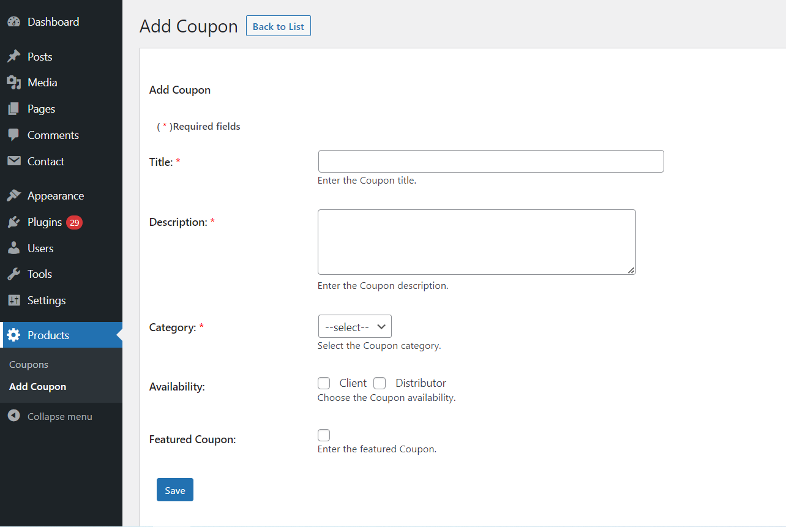Edit Page 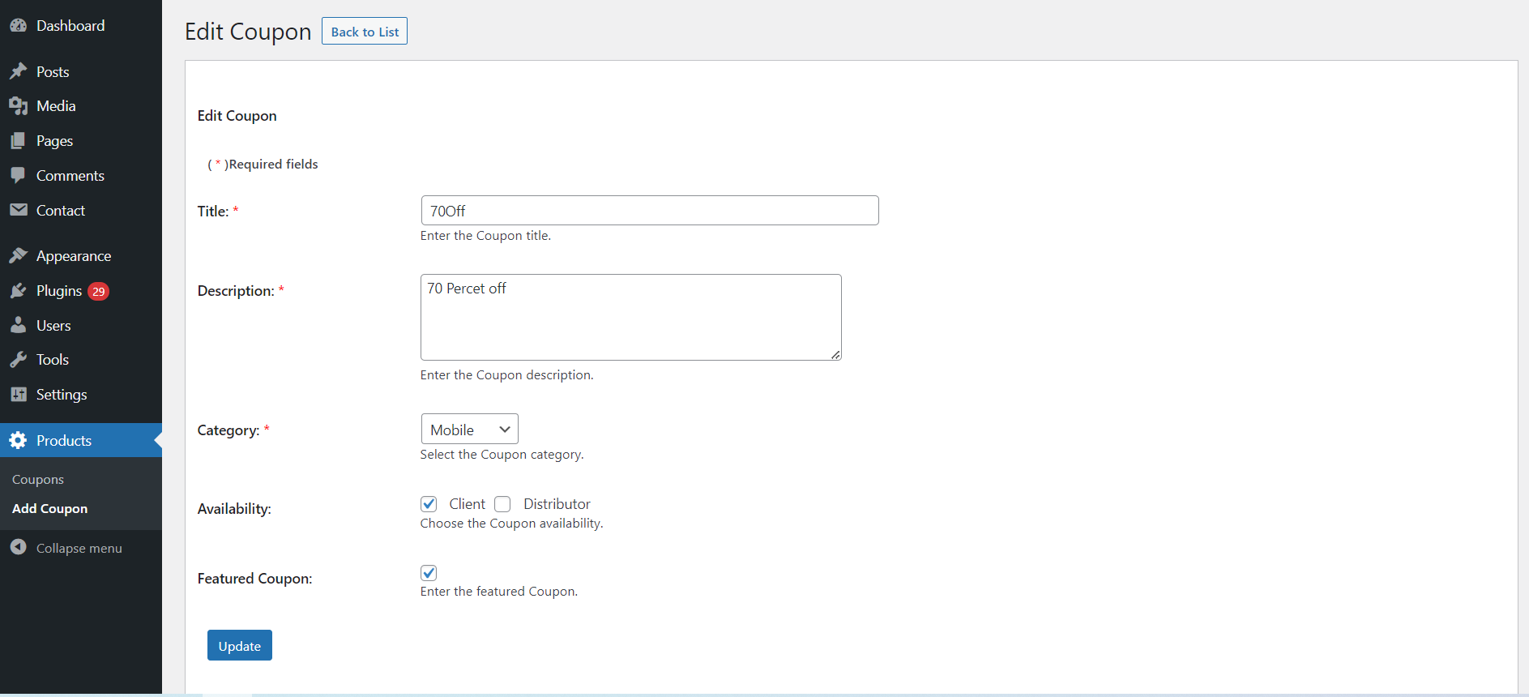

Listing page

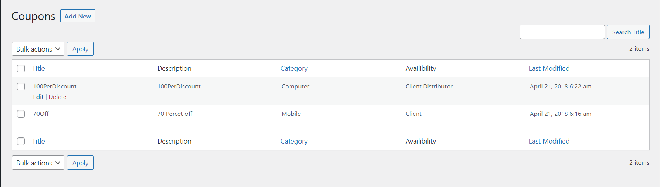

**Notes:**

1. All validation should be done on server-side, not html5 or jquery validation
2. If validation occurs then the rest of the data should remain in the field and should not be lost.
3. Do not use Bootstrap for CSS